武汉纺织大学

Java应用开发课程设计

**生活百宝箱程序**

**学 院： 数学与计算机学院**

**班 级： 软件11801**

**姓 名： 刘鑫**

**学 号： 1804240727**

**指导老师： 聂刚**

**成 绩：**

**完成日期： 2020年6月20日**

目 录

1 需求分析 1

1.1主菜单 1

1.2各项功能 1

1.2.1 手机号查询归属地查询 1

1.2.2 天气预报查询 1

1.2.3 ip地址查询 2

1.2.4 新闻头条查询 2

1.2.5 中英文双向翻译 2

1.2.6 退出 2

2 系统设计 3

2.1用户用例图 3

2.3 UML类图（Class Diagram） 3

2.4 UML时序图（Sequence Diagram） 4

3 系统实现 5

3.1 项目结构 5

3.2 配置文件 6

3.2.1 pom.xml文件 6

3.3 服务层APIService.java 7

3.4 服务层StringService.java 8

3.5 用户界面Driver.java 9

4 系统测试 12

5 系统总结 14

# 1 需求分析

使用Java语言开发一个生活百宝箱程序，当程序运行时，菜单功能显示如下：

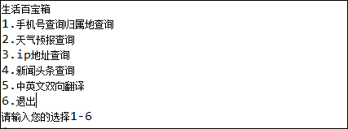

## 1.1主菜单

当用户名及密码正确时，进入系统主界面，如下：

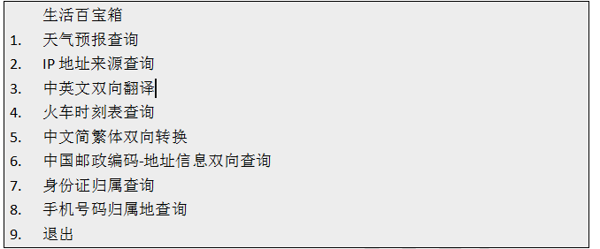

以上菜单功能可以任意更换为其他的功能，整个程序功能不能少于5个。

如果输入1-6以外的选择，则显示提示信息“输入无效，只能输入1-6”后，返回主界面。

## 1.2各项功能

### 1.2.1 手机号查询归属地查询

当选择1时，显示“请输入手机号（11位数字字符）：”，用户输入手机号后，如果输入不是11位数字字符或者不符合手机号的格式，则提示“手机号输入格式不正确，请重新输入”，直到输入格式正确，

调用淘宝提供的免费API进行查询，查询成功后会得到一个gson字符串，对gson字符串进行解析并输出里面的归属地信息，省份和城市，返回主菜单

### 1.2.2 天气预报查询

当选择2时，显示“请输入城市名称（中文）:”，如果输入格式不正确，则显示“你输入的城市格式不正确，请重新输入”，输入正确后，调用聚合提供的免费API进行查询，查询最近几天的天气信息，输出显示格式如下：

天气，温度，风向，风级，日期

小雨,34,南风,4-5级,2020-06-16

小雨,34,西南风,4-5级,2020-06-17

小雨,22,北风,3-5级,2020-06-18

多云,27,北风,微风,2020-06-19

中雨,28,东南风,微风,2020-06-20

### 1.2.3 ip地址查询

当选择3时，显示“请输入ip地址（111.11.11.1）：”，用户输入ip地址后，如果输入不符合ip地址的格式，则提示“ip地址输入格式不正确，请重新输入”，直到输入格式正确，

调用聚合提供的免费API进行查询，查询成功后会得到一个gson字符串，对gson字符串进行解析并输出里面的地址信息，国家，省份，城市，并输入显示，返回主菜单

中国,云南省,昆明市,电信

### 1.2.4 新闻头条查询

当选择4时，直接调用API进行查询各个网站的头条新闻，查询成功会得到一个gson字符串，对gson字符串解析输出里面的标题，日期和网站名称。返回主菜单

### 1.2.5 中英文双向翻译

当选择5时，显示如下子菜单：

1、中文转换英文

2、英文转换中文

3、返回主菜单

请选择（1-3）：

* 当选择1时，显示“请输入需要翻译的中文：”，用户输入后，如果输入不符合是中文，显示”输出格式错误，请重新输入”，直到输入正确为止。成功之后，调用百度翻译API进行翻译，请求成功之后得到一个gson字符串，解析之后输出译文，返回子菜单
* 当选择2时，显示“请输入需要翻译的英文：”，用户输入后，如果输入不符合是英文，显示”输出格式错误，请重新输入”，直到输入正确为止。成功之后，调用百度翻译API进行翻译，请求成功之后得到一个gson字符串，解析之后输出译文，返回子菜单
* 选择3时，返回到主菜单

### 1.2.6 退出

选择6时，显示” 程序退出！”，退出程序，。

# **2 系统设计**

## 2.1用户用例图

系统分为收银员，管理员两个角色，各角色的用户用例如下图2-1所示：

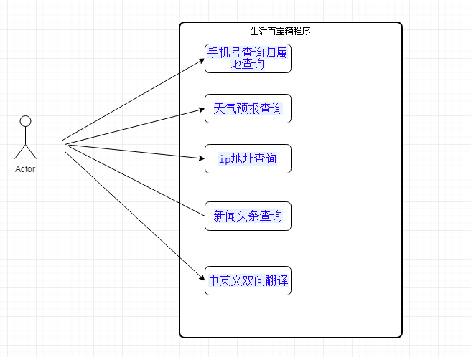

%3CmxGraphModel%3E%3Croot%3E%3CmxCell%20id%3D%220%22%2F%3E%3CmxCell%20id%3D%221%22%20parent%3D%220%22%2F%3E%3Cmysql.table%20entity.table.tableName%3D%22uses%22%20label%3D%22uses%22%20id%3D%222%22%3E%3CmxCell%20style%3D%22swimlane%3BfontStyle%3D0%3BchildLayout%3DstackLayout%3Bhorizontal%3D1%3Bhtml%3D1%3BstartSize%3D26%3BfillColor%3D%23b0e3e6%3BhorizontalStack%3D0%3BresizeParent%3D1%3BresizeParentMax%3D0%3BresizeLast%3D0%3Bcollapsible%3D1%3BmarginBottom%3D0%3BswimlaneFillColor%3D%23ffffff%3Balign%3Dcenter%3BfontSize%3D13%3BstrokeColor%3D%230e8088%3Brounded%3D0%3Bshadow%3D1%3Bcomic%3D0%3Bglass%3D0%3BgradientDirection%3Dsouth%3BgradientColor%3D%23ffffff%3B%22%20vertex%3D%221%22%20connectable%3D%220%22%20parent%3D%221%22%3E%3CmxGeometry%20x%3D%2260%22%20y%3D%2250%22%20width%3D%22310%22%20height%3D%22130%22%20as%3D%22geometry%22%2F%3E%3C%2FmxCell%3E%3C%2Fmysql.table%3E%3Cmysql.column%20entity.column.tableName%3D%22uses%22%20entity.column.name%3D%22userName%22%20entity.column.dataType%3D%22VARCHAR%22%20entity.column.PK%3D%22true%22%20label%3D%22%26lt%3Bimg%20title%3D%26quot%3BPrimary%20Key%26quot%3B%20src%3D%26quot%3Bimg%2Fdb%2Fkey1.png%26quot%3B%20width%3D%26quot%3B16%26quot%3B%20height%3D%26quot%3B16%26quot%3B%20align%3D%26quot%3Btop%26quot%3B%26gt%3B%26amp%3Bnbsp%3B%26lt%3Bfont%20size%3D%26quot%3B1%26quot%3B%20face%3D%26quot%3BTahoma%26quot%3B%26gt%3B%26lt%3Bspan%20style%3D%26quot%3Bfont-size%3A%2013px%26quot%3B%26gt%3B%26lt%3Bb%26gt%3Bid%20int%20primary%20key%26lt%3B%2Fb%26gt%3B%26lt%3B%2Fspan%26gt%3B%26lt%3B%2Ffont%26gt%3B%22%20entity.column.oldName%3D%22id%22%20entity.column.datalen%3D%2220%22%20entity.column.decimals%3D%22%22%20entity.column.autoIncreament%3D%22%22%20entity.column.unsigned%3D%22%22%20entity.column.bin%3D%22%22%20entity.column.ascii%3D%22%22%20entity.column.unicode%3D%22%22%20entity.column.unique%3D%22%22%20entity.column.isNotNull%3D%22NOT%20NULL%22%20entity.column.defaultValue%3D%22%22%20entity.column.comment%3D%22%22%20entity.column.enum%3D%22%22%20entity.column.set%3D%22%22%20entity.column.enumSetValue%3D%22%22%20id%3D%223%22%3E%3CmxCell%20style%3D%22text%3Bhtml%3D1%3BstrokeColor%3Dnone%3BfillColor%3Dnone%3BspacingLeft%3D4%3BspacingRight%3D4%3Boverflow%3Dhidden%3Brotatable%3D0%3BportConstraint%3Deastwest%3BfontSize%3D12%3BverticalAlign%3Dmiddle%3B%22%20vertex%3D%221%22%20parent%3D%222%22%3E%3CmxGeometry%20y%3D%2226%22%20width%3D%22310%22%20height%3D%2226%22%20as%3D%22geometry%22%2F%3E%3C%2FmxCell%3E%3C%2Fmysql.column%3E%3Cmysql.column%20entity.column.tableName%3D%22uses%22%20entity.column.name%3D%22chrName%22%20entity.column.datalen%3D%2220%22%20entity.column.dataType%3D%22VARCHAR%22%20label%3D%22%26lt%3Bimg%20title%3D%26quot%3BPrimary%20Key%26quot%3B%20src%3D%26quot%3Bimages%2Fspacer.gif%26quot%3B%20width%3D%26quot%3B16%26quot%3B%20height%3D%26quot%3B16%26quot%3B%20align%3D%26quot%3Btop%26quot%3B%26gt%3B%26amp%3Bnbsp%3B%26lt%3Bfont%20size%3D%26quot%3B1%26quot%3B%20face%3D%26quot%3BTahoma%26quot%3B%26gt%3B%26lt%3Bspan%20style%3D%26quot%3Bfont-size%3A%2013px%26quot%3B%26gt%3B%26lt%3Bb%26gt%3Bname%20varchar(10)%26lt%3B%2Fb%26gt%3B%26lt%3B%2Fspan%26gt%3B%26lt%3B%2Ffont%26gt%3B%22%20entity.column.oldName%3D%22name%22%20entity.column.decimals%3D%22%22%20entity.column.autoIncreament%3D%22%22%20entity.column.unsigned%3D%22%22%20entity.column.bin%3D%22%22%20entity.column.ascii%3D%22%22%20entity.column.unicode%3D%22%22%20entity.column.PK%3D%22false%22%20entity.column.unique%3D%22%22%20entity.column.isNotNull%3D%22%22%20entity.column.defaultValue%3D%22%22%20entity.column.comment%3D%22%22%20entity.column.enum%3D%22%22%20entity.column.set%3D%22%22%20entity.column.enumSetValue%3D%22%22%20id%3D%224%22%3E%3CmxCell%20style%3D%22text%3Bhtml%3D1%3BstrokeColor%3Dnone%3BfillColor%3Dnone%3BspacingLeft%3D4%3BspacingRight%3D4%3Boverflow%3Dhidden%3Brotatable%3D0%3BportConstraint%3Deastwest%3BfontSize%3D12%3BverticalAlign%3Dmiddle%3B%22%20vertex%3D%221%22%20parent%3D%222%22%3E%3CmxGeometry%20y%3D%2252%22%20width%3D%22310%22%20height%3D%2226%22%20as%3D%22geometry%22%2F%3E%3C%2FmxCell%3E%3C%2Fmysql.column%3E%3Cmysql.column%20entity.column.tableName%3D%22uses%22%20entity.column.name%3D%22password%22%20entity.column.datalen%3D%2250%22%20entity.column.dataType%3D%22VARCHAR%22%20label%3D%22%26lt%3Bimg%20title%3D%26quot%3BPrimary%20Key%26quot%3B%20src%3D%26quot%3Bimages%2Fspacer.gif%26quot%3B%20width%3D%26quot%3B16%26quot%3B%20height%3D%26quot%3B16%26quot%3B%20align%3D%26quot%3Btop%26quot%3B%26gt%3B%26amp%3Bnbsp%3B%26lt%3Bfont%20size%3D%26quot%3B1%26quot%3B%20face%3D%26quot%3BTahoma%26quot%3B%26gt%3B%26lt%3Bspan%20style%3D%26quot%3Bfont-size%3A%2013px%26quot%3B%26gt%3B%26lt%3Bb%26gt%3Bname%20varchar(10)%26lt%3B%2Fb%26gt%3B%26lt%3B%2Fspan%26gt%3B%26lt%3B%2Ffont%26gt%3B%22%20entity.column.oldName%3D%22chrName%22%20entity.column.decimals%3D%22%22%20entity.column.autoIncreament%3D%22%22%20entity.column.unsigned%3D%22%22%20entity.column.bin%3D%22%22%20entity.column.ascii%3D%22%22%20entity.column.unicode%3D%22%22%20entity.column.PK%3D%22false%22%20entity.column.unique%3D%22%22%20entity.column.isNotNull%3D%22%22%20entity.column.defaultValue%3D%22%22%20entity.column.comment%3D%22%E5%AF%86%E7%A0%81%22%20entity.column.enum%3D%22%22%20entity.column.set%3D%22%22%20entity.column.enumSetValue%3D%22%22%20id%3D%225%22%3E%3CmxCell%20style%3D%22text%3Bhtml%3D1%3BstrokeColor%3Dnone%3BfillColor%3Dnone%3BspacingLeft%3D4%3BspacingRight%3D4%3Boverflow%3Dhidden%3Brotatable%3D0%3BportConstraint%3Deastwest%3BfontSize%3D12%3BverticalAlign%3Dmiddle%3B%22%20vertex%3D%221%22%20parent%3D%222%22%3E%3CmxGeometry%20y%3D%2278%22%20width%3D%22310%22%20height%3D%2226%22%20as%3D%22geometry%22%2F%3E%3C%2FmxCell%3E%3C%2Fmysql.column%3E%3Cmysql.column%20entity.column.tableName%3D%22uses%22%20entity.column.name%3D%22role%22%20entity.column.datalen%3D%2220%22%20entity.column.dataType%3D%22VARCHAR%22%20label%3D%22%26lt%3Bimg%20title%3D%26quot%3BPrimary%20Key%26quot%3B%20src%3D%26quot%3Bimages%2Fspacer.gif%26quot%3B%20width%3D%26quot%3B16%26quot%3B%20height%3D%26quot%3B16%26quot%3B%20align%3D%26quot%3Btop%26quot%3B%26gt%3B%26amp%3Bnbsp%3B%26lt%3Bfont%20size%3D%26quot%3B1%26quot%3B%20face%3D%26quot%3BTahoma%26quot%3B%26gt%3B%26lt%3Bspan%20style%3D%26quot%3Bfont-size%3A%2013px%26quot%3B%26gt%3B%26lt%3Bb%26gt%3Bname%20varchar(10)%26lt%3B%2Fb%26gt%3B%26lt%3B%2Fspan%26gt%3B%26lt%3B%2Ffont%26gt%3B%22%20entity.column.oldName%3D%22chrName%22%20entity.column.decimals%3D%22%22%20entity.column.autoIncreament%3D%22%22%20entity.column.unsigned%3D%22%22%20entity.column.bin%3D%22%22%20entity.column.ascii%3D%22%22%20entity.column.unicode%3D%22%22%20entity.column.PK%3D%22false%22%20entity.column.unique%3D%22%22%20entity.column.isNotNull%3D%22%22%20entity.column.defaultValue%3D%22%22%20entity.column.comment%3D%22%E8%A7%92%E8%89%B2%22%20entity.column.enum%3D%22%22%20entity.column.set%3D%22%22%20entity.column.enumSetValue%3D%22%22%20id%3D%226%22%3E%3CmxCell%20style%3D%22text%3Bhtml%3D1%3BstrokeColor%3Dnone%3BfillColor%3Dnone%3BspacingLeft%3D4%3BspacingRight%3D4%3Boverflow%3Dhidden%3Brotatable%3D0%3BportConstraint%3Deastwest%3BfontSize%3D12%3BverticalAlign%3Dmiddle%3B%22%20vertex%3D%221%22%20parent%3D%222%22%3E%3CmxGeometry%20y%3D%22104%22%20width%3D%22310%22%20height%3D%2226%22%20as%3D%22geometry%22%2F%3E%3C%2FmxCell%3E%3C%2Fmysql.column%3E%3Cmysql.table%20entity.table.tableName%3D%22product%22%20label%3D%22product%22%20id%3D%227%22%3E%3CmxCell%20style%3D%22swimlane%3BfontStyle%3D0%3BchildLayout%3DstackLayout%3Bhorizontal%3D1%3Bhtml%3D1%3BstartSize%3D26%3BfillColor%3D%23b0e3e6%3BhorizontalStack%3D0%3BresizeParent%3D1%3BresizeParentMax%3D0%3BresizeLast%3D0%3Bcollapsible%3D1%3BmarginBottom%3D0%3BswimlaneFillColor%3D%23ffffff%3Balign%3Dcenter%3BfontSize%3D13%3BstrokeColor%3D%230e8088%3Brounded%3D0%3Bshadow%3D1%3Bcomic%3D0%3Bglass%3D0%3BgradientDirection%3Dsouth%3BgradientColor%3D%23ffffff%3B%22%20vertex%3D%221%22%20connectable%3D%220%22%20parent%3D%221%22%3E%3CmxGeometry%20x%3D%2260%22%20y%3D%22210%22%20width%3D%22310%22%20height%3D%22130%22%20as%3D%22geometry%22%2F%3E%3C%2FmxCell%3E%3C%2Fmysql.table%3E%3Cmysql.column%20entity.column.tableName%3D%22product%22%20entity.column.name%3D%22barcode%22%20entity.column.dataType%3D%22VARCHAR%22%20entity.column.PK%3D%22true%22%20label%3D%22%26lt%3Bimg%20title%3D%26quot%3BPrimary%20Key%26quot%3B%20src%3D%26quot%3Bimg%2Fdb%2Fkey1.png%26quot%3B%20width%3D%26quot%3B16%26quot%3B%20height%3D%26quot%3B16%26quot%3B%20align%3D%26quot%3Btop%26quot%3B%26gt%3B%26amp%3Bnbsp%3B%26lt%3Bfont%20size%3D%26quot%3B1%26quot%3B%20face%3D%26quot%3BTahoma%26quot%3B%26gt%3B%26lt%3Bspan%20style%3D%26quot%3Bfont-size%3A%2013px%26quot%3B%26gt%3B%26lt%3Bb%26gt%3Bid%20int%20primary%20key%26lt%3B%2Fb%26gt%3B%26lt%3B%2Fspan%26gt%3B%26lt%3B%2Ffont%26gt%3B%22%20entity.column.oldName%3D%22id%22%20entity.column.datalen%3D%2210%22%20entity.column.decimals%3D%22%22%20entity.column.autoIncreament%3D%22%22%20entity.column.unsigned%3D%22%22%20entity.column.bin%3D%22%22%20entity.column.ascii%3D%22%22%20entity.column.unicode%3D%22%22%20entity.column.unique%3D%22%22%20entity.column.isNotNull%3D%22NOT%20NULL%22%20entity.column.defaultValue%3D%22%22%20entity.column.comment%3D%22%22%20entity.column.enum%3D%22%22%20entity.column.set%3D%22%22%20entity.column.enumSetValue%3D%22%22%20id%3D%228%22%3E%3CmxCell%20style%3D%22text%3Bhtml%3D1%3BstrokeColor%3Dnone%3BfillColor%3Dnone%3BspacingLeft%3D4%3BspacingRight%3D4%3Boverflow%3Dhidden%3Brotatable%3D0%3BportConstraint%3Deastwest%3BfontSize%3D12%3BverticalAlign%3Dmiddle%3B%22%20vertex%3D%221%22%20parent%3D%227%22%3E%3CmxGeometry%20y%3D%2226%22%20width%3D%22310%22%20height%3D%2226%22%20as%3D%22geometry%22%2F%3E%3C%2FmxCell%3E%3C%2Fmysql.column%3E%3Cmysql.column%20entity.column.tableName%3D%22product%22%20entity.column.name%3D%22productName%22%20entity.column.datalen%3D%2250%22%20entity.column.dataType%3D%22VARCHAR%22%20label%3D%22%26lt%3Bimg%20title%3D%26quot%3BPrimary%20Key%26quot%3B%20src%3D%26quot%3Bimages%2Fspacer.gif%26quot%3B%20width%3D%26quot%3B16%26quot%3B%20height%3D%26quot%3B16%26quot%3B%20align%3D%26quot%3Btop%26quot%3B%26gt%3B%26amp%3Bnbsp%3B%26lt%3Bfont%20size%3D%26quot%3B1%26quot%3B%20face%3D%26quot%3BTahoma%26quot%3B%26gt%3B%26lt%3Bspan%20style%3D%26quot%3Bfont-size%3A%2013px%26quot%3B%26gt%3B%26lt%3Bb%26gt%3Bname%20varchar(10)%26lt%3B%2Fb%26gt%3B%26lt%3B%2Fspan%26gt%3B%26lt%3B%2Ffont%26gt%3B%22%20entity.column.oldName%3D%22name%22%20entity.column.decimals%3D%22%22%20entity.column.autoIncreament%3D%22%22%20entity.column.unsigned%3D%22%22%20entity.column.bin%3D%22%22%20entity.column.ascii%3D%22%22%20entity.column.unicode%3D%22%22%20entity.column.PK%3D%22false%22%20entity.column.unique%3D%22%22%20entity.column.isNotNull%3D%22%22%20entity.column.defaultValue%3D%22%22%20entity.column.comment%3D%22%22%20entity.column.enum%3D%22%22%20entity.column.set%3D%22%22%20entity.column.enumSetValue%3D%22%22%20id%3D%229%22%3E%3CmxCell%20style%3D%22text%3Bhtml%3D1%3BstrokeColor%3Dnone%3BfillColor%3Dnone%3BspacingLeft%3D4%3BspacingRight%3D4%3Boverflow%3Dhidden%3Brotatable%3D0%3BportConstraint%3Deastwest%3BfontSize%3D12%3BverticalAlign%3Dmiddle%3B%22%20vertex%3D%221%22%20parent%3D%227%22%3E%3CmxGeometry%20y%3D%2252%22%20width%3D%22310%22%20height%3D%2226%22%20as%3D%22geometry%22%2F%3E%3C%2FmxCell%3E%3C%2Fmysql.column%3E%3Cmysql.column%20entity.column.tableName%3D%22product%22%20entity.column.name%3D%22price%22%20entity.column.datalen%3D%229%22%20entity.column.dataType%3D%22DECIMAL%22%20label%3D%22%26lt%3Bimg%20title%3D%26quot%3BPrimary%20Key%26quot%3B%20src%3D%26quot%3Bimages%2Fspacer.gif%26quot%3B%20width%3D%26quot%3B16%26quot%3B%20height%3D%26quot%3B16%26quot%3B%20align%3D%26quot%3Btop%26quot%3B%26gt%3B%26amp%3Bnbsp%3B%26lt%3Bfont%20size%3D%26quot%3B1%26quot%3B%20face%3D%26quot%3BTahoma%26quot%3B%26gt%3B%26lt%3Bspan%20style%3D%26quot%3Bfont-size%3A%2013px%26quot%3B%26gt%3B%26lt%3Bb%26gt%3Bname%20varchar(10)%26lt%3B%2Fb%26gt%3B%26lt%3B%2Fspan%26gt%3B%26lt%3B%2Ffont%26gt%3B%22%20entity.column.oldName%3D%22price%22%20entity.column.decimals%3D%222%22%20entity.column.autoIncreament%3D%22%22%20entity.column.unsigned%3D%22%22%20entity.column.bin%3D%22%22%20entity.column.ascii%3D%22%22%20entity.column.unicode%3D%22%22%20entity.column.PK%3D%22false%22%20entity.column.unique%3D%22%22%20entity.column.isNotNull%3D%22%22%20entity.column.defaultValue%3D%22%22%20entity.column.comment%3D%22%22%20entity.column.enum%3D%22%22%20entity.column.set%3D%22%22%20entity.column.enumSetValue%3D%22%22%20id%3D%2210%22%3E%3CmxCell%20style%3D%22text%3Bhtml%3D1%3BstrokeColor%3Dnone%3BfillColor%3Dnone%3BspacingLeft%3D4%3BspacingRight%3D4%3Boverflow%3Dhidden%3Brotatable%3D0%3BportConstraint%3Deastwest%3BfontSize%3D12%3BverticalAlign%3Dmiddle%3B%22%20vertex%3D%221%22%20parent%3D%227%22%3E%3CmxGeometry%20y%3D%2278%22%20width%3D%22310%22%20height%3D%2226%22%20as%3D%22geometry%22%2F%3E%3C%2FmxCell%3E%3C%2Fmysql.column%3E%3Cmysql.column%20entity.column.tableName%3D%22product%22%20entity.column.name%3D%22supply%22%20entity.column.datalen%3D%2220%22%20entity.column.dataType%3D%22VARCHAR%22%20label%3D%22%26lt%3Bimg%20title%3D%26quot%3BPrimary%20Key%26quot%3B%20src%3D%26quot%3Bimages%2Fspacer.gif%26quot%3B%20width%3D%26quot%3B16%26quot%3B%20height%3D%26quot%3B16%26quot%3B%20align%3D%26quot%3Btop%26quot%3B%26gt%3B%26amp%3Bnbsp%3B%26lt%3Bfont%20size%3D%26quot%3B1%26quot%3B%20face%3D%26quot%3BTahoma%26quot%3B%26gt%3B%26lt%3Bspan%20style%3D%26quot%3Bfont-size%3A%2013px%26quot%3B%26gt%3B%26lt%3Bb%26gt%3Bname%20varchar(10)%26lt%3B%2Fb%26gt%3B%26lt%3B%2Fspan%26gt%3B%26lt%3B%2Ffont%26gt%3B%22%20entity.column.oldName%3D%22price%22%20entity.column.decimals%3D%22%22%20entity.column.autoIncreament%3D%22%22%20entity.column.unsigned%3D%22%22%20entity.column.bin%3D%22%22%20entity.column.ascii%3D%22%22%20entity.column.unicode%3D%22%22%20entity.column.PK%3D%22false%22%20entity.column.unique%3D%22%22%20entity.column.isNotNull%3D%22%22%20entity.column.defaultValue%3D%22%22%20entity.column.comment%3D%22%22%20entity.column.enum%3D%22%22%20entity.column.set%3D%22%22%20entity.column.enumSetValue%3D%22%22%20id%3D%2211%22%3E%3CmxCell%20style%3D%22text%3Bhtml%3D1%3BstrokeColor%3Dnone%3BfillColor%3Dnone%3BspacingLeft%3D4%3BspacingRight%3D4%3Boverflow%3Dhidden%3Brotatable%3D0%3BportConstraint%3Deastwest%3BfontSize%3D12%3BverticalAlign%3Dmiddle%3B%22%20vertex%3D%221%22%20parent%3D%227%22%3E%3CmxGeometry%20y%3D%22104%22%20width%3D%22310%22%20height%3D%2226%22%20as%3D%22geometry%22%2F%3E%3C%2FmxCell%3E%3C%2Fmysql.column%3E%3Cmysql.table%20entity.table.tableName%3D%22saleDetail%22%20label%3D%22saleDetail%22%20id%3D%2212%22%3E%3CmxCell%20style%3D%22swimlane%3BfontStyle%3D0%3BchildLayout%3DstackLayout%3Bhorizontal%3D1%3Bhtml%3D1%3BstartSize%3D26%3BfillColor%3D%23b0e3e6%3BhorizontalStack%3D0%3BresizeParent%3D1%3BresizeParentMax%3D0%3BresizeLast%3D0%3Bcollapsible%3D1%3BmarginBottom%3D0%3BswimlaneFillColor%3D%23ffffff%3Balign%3Dcenter%3BfontSize%3D13%3BstrokeColor%3D%230e8088%3Brounded%3D0%3Bshadow%3D1%3Bcomic%3D0%3Bglass%3D0%3BgradientDirection%3Dsouth%3BgradientColor%3D%23ffffff%3B%22%20vertex%3D%221%22%20connectable%3D%220%22%20parent%3D%221%22%3E%3CmxGeometry%20x%3D%22480%22%20y%3D%2280%22%20width%3D%22280%22%20height%3D%22208%22%20as%3D%22geometry%22%2F%3E%3C%2FmxCell%3E%3C%2Fmysql.table%3E%3Cmysql.column%20entity.column.tableName%3D%22saleDetail%22%20entity.column.name%3D%22lsh%22%20entity.column.dataType%3D%22VARCHAR%22%20entity.column.PK%3D%22true%22%20label%3D%22%26lt%3Bimg%20title%3D%26quot%3BPrimary%20Key%26quot%3B%20src%3D%26quot%3Bimg%2Fdb%2Fkey1.png%26quot%3B%20width%3D%26quot%3B16%26quot%3B%20height%3D%26quot%3B16%26quot%3B%20align%3D%26quot%3Btop%26quot%3B%26gt%3B%26amp%3Bnbsp%3B%26lt%3Bfont%20size%3D%26quot%3B1%26quot%3B%20face%3D%26quot%3BTahoma%26quot%3B%26gt%3B%26lt%3Bspan%20style%3D%26quot%3Bfont-size%3A%2013px%26quot%3B%26gt%3B%26lt%3Bb%26gt%3Bid%20int%20primary%20key%26lt%3B%2Fb%26gt%3B%26lt%3B%2Fspan%26gt%3B%26lt%3B%2Ffont%26gt%3B%22%20entity.column.oldName%3D%22id%22%20entity.column.datalen%3D%2220%22%20entity.column.decimals%3D%22%22%20entity.column.autoIncreament%3D%22%22%20entity.column.unsigned%3D%22%22%20entity.column.bin%3D%22%22%20entity.column.ascii%3D%22%22%20entity.column.unicode%3D%22%22%20entity.column.unique%3D%22%22%20entity.column.isNotNull%3D%22NOT%20NULL%22%20entity.column.defaultValue%3D%22%22%20entity.column.comment%3D%22%22%20entity.column.enum%3D%22%22%20entity.column.set%3D%22%22%20entity.column.enumSetValue%3D%22%22%20id%3D%2213%22%3E%3CmxCell%20style%3D%22text%3Bhtml%3D1%3BstrokeColor%3Dnone%3BfillColor%3Dnone%3BspacingLeft%3D4%3BspacingRight%3D4%3Boverflow%3Dhidden%3Brotatable%3D0%3BportConstraint%3Deastwest%3BfontSize%3D12%3BverticalAlign%3Dmiddle%3B%22%20vertex%3D%221%22%20parent%3D%2212%22%3E%3CmxGeometry%20y%3D%2226%22%20width%3D%22280%22%20height%3D%2226%22%20as%3D%22geometry%22%2F%3E%3C%2FmxCell%3E%3C%2Fmysql.column%3E%3Cmysql.column%20entity.column.tableName%3D%22saleDetail%22%20entity.column.name%3D%22barcode%22%20entity.column.datalen%3D%2210%22%20entity.column.dataType%3D%22VARCHAR%22%20label%3D%22%26lt%3Bimg%20title%3D%26quot%3BPrimary%20Key%26quot%3B%20src%3D%26quot%3Bimages%2Fspacer.gif%26quot%3B%20width%3D%26quot%3B16%26quot%3B%20height%3D%26quot%3B16%26quot%3B%20align%3D%26quot%3Btop%26quot%3B%26gt%3B%26amp%3Bnbsp%3B%26lt%3Bfont%20size%3D%26quot%3B1%26quot%3B%20face%3D%26quot%3BTahoma%26quot%3B%26gt%3B%26lt%3Bspan%20style%3D%26quot%3Bfont-size%3A%2013px%26quot%3B%26gt%3B%26lt%3Bb%26gt%3Bname%20varchar(10)%26lt%3B%2Fb%26gt%3B%26lt%3B%2Fspan%26gt%3B%26lt%3B%2Ffont%26gt%3B%22%20entity.column.oldName%3D%22barcode%22%20entity.column.decimals%3D%22%22%20entity.column.autoIncreament%3D%22%22%20entity.column.unsigned%3D%22%22%20entity.column.bin%3D%22%22%20entity.column.ascii%3D%22%22%20entity.column.unicode%3D%22%22%20entity.column.PK%3D%22false%22%20entity.column.unique%3D%22%22%20entity.column.isNotNull%3D%22%22%20entity.column.defaultValue%3D%22%22%20entity.column.comment%3D%22%22%20entity.column.enum%3D%22%22%20entity.column.set%3D%22%22%20entity.column.enumSetValue%3D%22%22%20id%3D%2214%22%3E%3CmxCell%20style%3D%22text%3Bhtml%3D1%3BstrokeColor%3Dnone%3BfillColor%3Dnone%3BspacingLeft%3D4%3BspacingRight%3D4%3Boverflow%3Dhidden%3Brotatable%3D0%3BportConstraint%3Deastwest%3BfontSize%3D12%3BverticalAlign%3Dmiddle%3B%22%20vertex%3D%221%22%20parent%3D%2212%22%3E%3CmxGeometry%20y%3D%2252%22%20width%3D%22280%22%20height%3D%2226%22%20as%3D%22geometry%22%2F%3E%3C%2FmxCell%3E%3C%2Fmysql.column%3E%3Cmysql.column%20entity.column.tableName%3D%22saleDetail%22%20entity.column.name%3D%22productName%22%20entity.column.datalen%3D%2250%22%20entity.column.dataType%3D%22VARCHAR%22%20label%3D%22%26lt%3Bimg%20title%3D%26quot%3BPrimary%20Key%26quot%3B%20src%3D%26quot%3Bimages%2Fspacer.gif%26quot%3B%20width%3D%26quot%3B16%26quot%3B%20height%3D%26quot%3B16%26quot%3B%20align%3D%26quot%3Btop%26quot%3B%26gt%3B%26amp%3Bnbsp%3B%26lt%3Bfont%20size%3D%26quot%3B1%26quot%3B%20face%3D%26quot%3BTahoma%26quot%3B%26gt%3B%26lt%3Bspan%20style%3D%26quot%3Bfont-size%3A%2013px%26quot%3B%26gt%3B%26lt%3Bb%26gt%3Bname%20varchar(10)%26lt%3B%2Fb%26gt%3B%26lt%3B%2Fspan%26gt%3B%26lt%3B%2Ffont%26gt%3B%22%20entity.column.oldName%3D%22productName%22%20entity.column.decimals%3D%22%22%20entity.column.autoIncreament%3D%22%22%20entity.column.unsigned%3D%22%22%20entity.column.bin%3D%22%22%20entity.column.ascii%3D%22%22%20entity.column.unicode%3D%22%22%20entity.column.PK%3D%22false%22%20entity.column.unique%3D%22%22%20entity.column.isNotNull%3D%22%22%20entity.column.defaultValue%3D%22%22%20entity.column.comment%3D%22%22%20entity.column.enum%3D%22%22%20entity.column.set%3D%22%22%20entity.column.enumSetValue%3D%22%22%20id%3D%2215%22%3E%3CmxCell%20style%3D%22text%3Bhtml%3D1%3BstrokeColor%3Dnone%3BfillColor%3Dnone%3BspacingLeft%3D4%3BspacingRight%3D4%3Boverflow%3Dhidden%3Brotatable%3D0%3BportConstraint%3Deastwest%3BfontSize%3D12%3BverticalAlign%3Dmiddle%3B%22%20vertex%3D%221%22%20parent%3D%2212%22%3E%3CmxGeometry%20y%3D%2278%22%20width%3D%22280%22%20height%3D%2226%22%20as%3D%22geometry%22%2F%3E%3C%2FmxCell%3E%3C%2Fmysql.column%3E%3Cmysql.column%20entity.column.tableName%3D%22saleDetail%22%20entity.column.name%3D%22price%22%20entity.column.datalen%3D%229%22%20entity.column.dataType%3D%22DECIMAL%22%20label%3D%22%26lt%3Bimg%20title%3D%26quot%3BPrimary%20Key%26quot%3B%20src%3D%26quot%3Bimages%2Fspacer.gif%26quot%3B%20width%3D%26quot%3B16%26quot%3B%20height%3D%26quot%3B16%26quot%3B%20align%3D%26quot%3Btop%26quot%3B%26gt%3B%26amp%3Bnbsp%3B%26lt%3Bfont%20size%3D%26quot%3B1%26quot%3B%20face%3D%26quot%3BTahoma%26quot%3B%26gt%3B%26lt%3Bspan%20style%3D%26quot%3Bfont-size%3A%2013px%26quot%3B%26gt%3B%26lt%3Bb%26gt%3Bname%20varchar(10)%26lt%3B%2Fb%26gt%3B%26lt%3B%2Fspan%26gt%3B%26lt%3B%2Ffont%26gt%3B%22%20entity.column.oldName%3D%22productName%22%20entity.column.decimals%3D%222%22%20entity.column.autoIncreament%3D%22%22%20entity.column.unsigned%3D%22%22%20entity.column.bin%3D%22%22%20entity.column.ascii%3D%22%22%20entity.column.unicode%3D%22%22%20entity.column.PK%3D%22false%22%20entity.column.unique%3D%22%22%20entity.column.isNotNull%3D%22%22%20entity.column.defaultValue%3D%22%22%20entity.column.comment%3D%22%22%20entity.column.enum%3D%22%22%20entity.column.set%3D%22%22%20entity.column.enumSetValue%3D%22%22%20id%3D%2216%22%3E%3CmxCell%20style%3D%22text%3Bhtml%3D1%3BstrokeColor%3Dnone%3BfillColor%3Dnone%3BspacingLeft%3D4%3BspacingRight%3D4%3Boverflow%3Dhidden%3Brotatable%3D0%3BportConstraint%3Deastwest%3BfontSize%3D12%3BverticalAlign%3Dmiddle%3B%22%20vertex%3D%221%22%20parent%3D%2212%22%3E%3CmxGeometry%20y%3D%22104%22%20width%3D%22280%22%20height%3D%2226%22%20as%3D%22geometry%22%2F%3E%3C%2FmxCell%3E%3C%2Fmysql.column%3E%3Cmysql.column%20entity.column.tableName%3D%22saleDetail%22%20entity.column.name%3D%22count%22%20entity.column.datalen%3D%229%22%20entity.column.dataType%3D%22INT%22%20label%3D%22%26lt%3Bimg%20title%3D%26quot%3BPrimary%20Key%26quot%3B%20src%3D%26quot%3Bimages%2Fspacer.gif%26quot%3B%20width%3D%26quot%3B16%26quot%3B%20height%3D%26quot%3B16%26quot%3B%20align%3D%26quot%3Btop%26quot%3B%26gt%3B%26amp%3Bnbsp%3B%26lt%3Bfont%20size%3D%26quot%3B1%26quot%3B%20face%3D%26quot%3BTahoma%26quot%3B%26gt%3B%26lt%3Bspan%20style%3D%26quot%3Bfont-size%3A%2013px%26quot%3B%26gt%3B%26lt%3Bb%26gt%3Bname%20varchar(10)%26lt%3B%2Fb%26gt%3B%26lt%3B%2Fspan%26gt%3B%26lt%3B%2Ffont%26gt%3B%22%20entity.column.oldName%3D%22price%22%20entity.column.decimals%3D%22%22%20entity.column.autoIncreament%3D%22%22%20entity.column.unsigned%3D%22%22%20entity.column.bin%3D%22%22%20entity.column.ascii%3D%22%22%20entity.column.unicode%3D%22%22%20entity.column.PK%3D%22false%22%20entity.column.unique%3D%22%22%20entity.column.isNotNull%3D%22%22%20entity.column.defaultValue%3D%22%22%20entity.column.comment%3D%22%22%20entity.column.enum%3D%22%22%20entity.column.set%3D%22%22%20entity.column.enumSetValue%3D%22%22%20id%3D%2217%22%3E%3CmxCell%20style%3D%22text%3Bhtml%3D1%3BstrokeColor%3Dnone%3BfillColor%3Dnone%3BspacingLeft%3D4%3BspacingRight%3D4%3Boverflow%3Dhidden%3Brotatable%3D0%3BportConstraint%3Deastwest%3BfontSize%3D12%3BverticalAlign%3Dmiddle%3B%22%20vertex%3D%221%22%20parent%3D%2212%22%3E%3CmxGeometry%20y%3D%22130%22%20width%3D%22280%22%20height%3D%2226%22%20as%3D%22geometry%22%2F%3E%3C%2FmxCell%3E%3C%2Fmysql.column%3E%3Cmysql.column%20entity.column.tableName%3D%22saleDetail%22%20entity.column.name%3D%22operator%22%20entity.column.datalen%3D%2220%22%20entity.column.dataType%3D%22VARCHAR%22%20label%3D%22%26lt%3Bimg%20title%3D%26quot%3BPrimary%20Key%26quot%3B%20src%3D%26quot%3Bimages%2Fspacer.gif%26quot%3B%20width%3D%26quot%3B16%26quot%3B%20height%3D%26quot%3B16%26quot%3B%20align%3D%26quot%3Btop%26quot%3B%26gt%3B%26amp%3Bnbsp%3B%26lt%3Bfont%20size%3D%26quot%3B1%26quot%3B%20face%3D%26quot%3BTahoma%26quot%3B%26gt%3B%26lt%3Bspan%20style%3D%26quot%3Bfont-size%3A%2013px%26quot%3B%26gt%3B%26lt%3Bb%26gt%3Bname%20varchar(10)%26lt%3B%2Fb%26gt%3B%26lt%3B%2Fspan%26gt%3B%26lt%3B%2Ffont%26gt%3B%22%20entity.column.oldName%3D%22count%22%20entity.column.decimals%3D%22%22%20entity.column.autoIncreament%3D%22%22%20entity.column.unsigned%3D%22%22%20entity.column.bin%3D%22%22%20entity.column.ascii%3D%22%22%20entity.column.unicode%3D%22%22%20entity.column.PK%3D%22false%22%20entity.column.unique%3D%22%22%20entity.column.isNotNull%3D%22%22%20entity.column.defaultValue%3D%22%22%20entity.column.comment%3D%22%22%20entity.column.enum%3D%22%22%20entity.column.set%3D%22%22%20entity.column.enumSetValue%3D%22%22%20id%3D%2218%22%3E%3CmxCell%20style%3D%22text%3Bhtml%3D1%3BstrokeColor%3Dnone%3BfillColor%3Dnone%3BspacingLeft%3D4%3BspacingRight%3D4%3Boverflow%3Dhidden%3Brotatable%3D0%3BportConstraint%3Deastwest%3BfontSize%3D12%3BverticalAlign%3Dmiddle%3B%22%20vertex%3D%221%22%20parent%3D%2212%22%3E%3CmxGeometry%20y%3D%22156%22%20width%3D%22280%22%20height%3D%2226%22%20as%3D%22geometry%22%2F%3E%3C%2FmxCell%3E%3C%2Fmysql.column%3E%3Cmysql.column%20entity.column.tableName%3D%22saleDetail%22%20entity.column.name%3D%22saleTime%22%20entity.column.datalen%3D%22%22%20entity.column.dataType%3D%22DATETIME%22%20label%3D%22%26lt%3Bimg%20title%3D%26quot%3BPrimary%20Key%26quot%3B%20src%3D%26quot%3Bimages%2Fspacer.gif%26quot%3B%20width%3D%26quot%3B16%26quot%3B%20height%3D%26quot%3B16%26quot%3B%20align%3D%26quot%3Btop%26quot%3B%26gt%3B%26amp%3Bnbsp%3B%26lt%3Bfont%20size%3D%26quot%3B1%26quot%3B%20face%3D%26quot%3BTahoma%26quot%3B%26gt%3B%26lt%3Bspan%20style%3D%26quot%3Bfont-size%3A%2013px%26quot%3B%26gt%3B%26lt%3Bb%26gt%3Bname%20varchar(10)%26lt%3B%2Fb%26gt%3B%26lt%3B%2Fspan%26gt%3B%26lt%3B%2Ffont%26gt%3B%22%20entity.column.oldName%3D%22count%22%20entity.column.decimals%3D%22%22%20entity.column.autoIncreament%3D%22%22%20entity.column.unsigned%3D%22%22%20entity.column.bin%3D%22%22%20entity.column.ascii%3D%22%22%20entity.column.unicode%3D%22%22%20entity.column.PK%3D%22false%22%20entity.column.unique%3D%22%22%20entity.column.isNotNull%3D%22%22%20entity.column.defaultValue%3D%22%22%20entity.column.comment%3D%22%22%20entity.column.enum%3D%22%22%20entity.column.set%3D%22%22%20entity.column.enumSetValue%3D%22%22%20id%3D%2219%22%3E%3CmxCell%20style%3D%22text%3Bhtml%3D1%3BstrokeColor%3Dnone%3BfillColor%3Dnone%3BspacingLeft%3D4%3BspacingRight%3D4%3Boverflow%3Dhidden%3Brotatable%3D0%3BportConstraint%3Deastwest%3BfontSize%3D12%3BverticalAlign%3Dmiddle%3B%22%20vertex%3D%221%22%20parent%3D%2212%22%3E%3CmxGeometry%20y%3D%22182%22%20width%3D%22280%22%20height%3D%2226%22%20as%3D%22geometry%22%2F%3E%3C%2FmxCell%3E%3C%2Fmysql.column%3E%3CmxCell%20id%3D%2220%22%20value%3D%221..n%22%20style%3D%22edgeStyle%3DentityRelationEdgeStyle%3BfontSize%3D12%3Bhtml%3D1%3BendArrow%3DERoneToMany%3BstrokeWidth%3D2%3BstrokeColor%3D%236c8ebf%3BexitX%3D1%3BexitY%3D0.25%3BentryX%3D0%3BentryY%3D0.5%3B%22%20edge%3D%221%22%20source%3D%224%22%20target%3D%2214%22%20parent%3D%221%22%3E%3CmxGeometry%20relative%3D%221%22%20as%3D%22geometry%22%2F%3E%3C%2FmxCell%3E%3CmxCell%20id%3D%2221%22%20value%3D%221..n%22%20style%3D%22edgeStyle%3DentityRelationEdgeStyle%3BfontSize%3D12%3Bhtml%3D1%3BendArrow%3DERoneToMany%3BstrokeWidth%3D2%3BstrokeColor%3D%236c8ebf%3BexitX%3D1%3BexitY%3D0.5%3BentryX%3D0%3BentryY%3D0.5%3B%22%20edge%3D%221%22%20source%3D%228%22%20target%3D%2216%22%20parent%3D%221%22%3E%3CmxGeometry%20relative%3D%221%22%20as%3D%22geometry%22%2F%3E%3C%2FmxCell%3E%3C%2Froot%3E%3C%2FmxGraphModel%3E

## 2.3 UML类图（Class Diagram）

对于用户功能模块，共设计如下3个类。

* Api调用类APIService:用户选择哪个功能的时候就调用对应的网络API
* Gson字符串处理类：调用APi类得到的返回结果是一个json字符串，然后调用对应的字符串处理方法，进行输出
* Drive类：用户的界面操作

各类的结构及类之间的关系如图2-5所示：

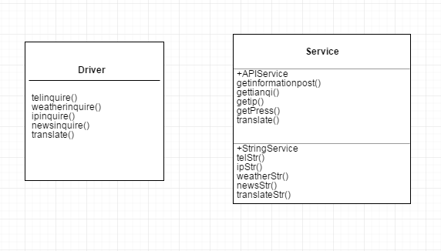

图2-5 用户功能类图

## 2.4 UML时序图（Sequence Diagram）

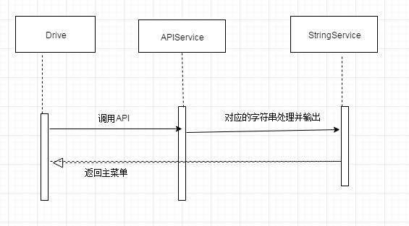

# **3 系统实现**

## 3.1 项目结构

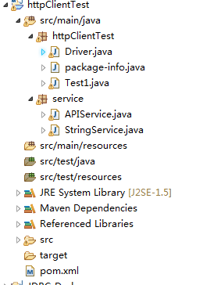

## 3.2 配置文件

### 3.2.1 pom.xml文件

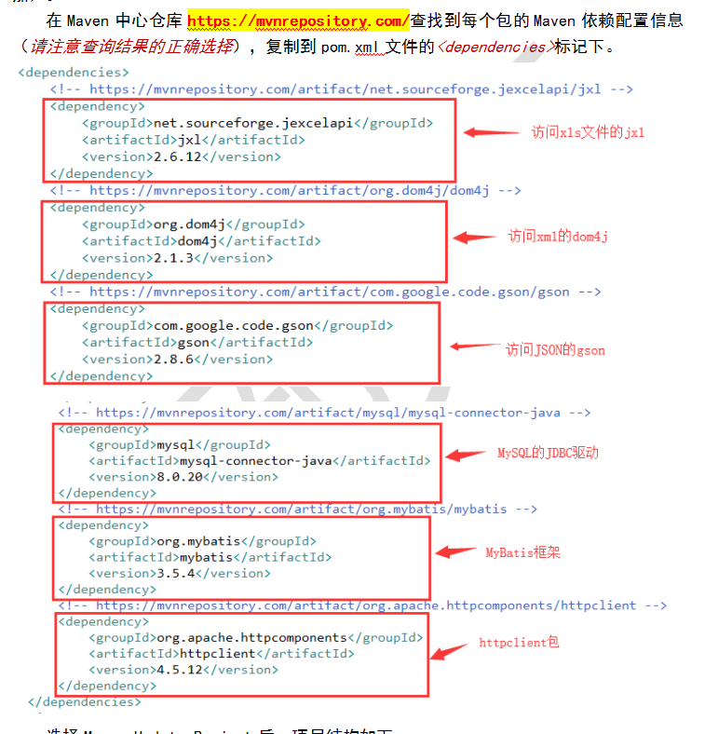

## 3.3 服务层APIService.java

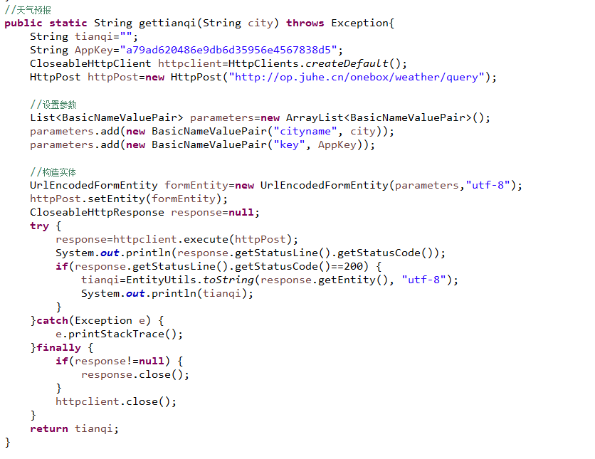

城市名称作为参数传入，调用网络上的免费API进行查询，得到的天气信息并返回一个字符串

首先把API分配给我们的密钥存下来AppKey,



创建连接访问API,里面的是API的连接地址

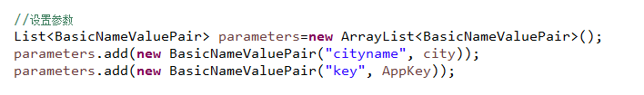

设置参数，查询的城市名称，还有分配给我们的密钥作为参数传入。

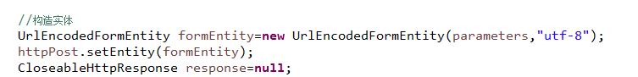

构造实体

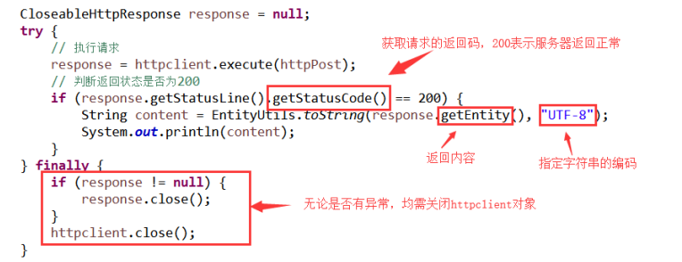

最后一定要关闭httpclient对象

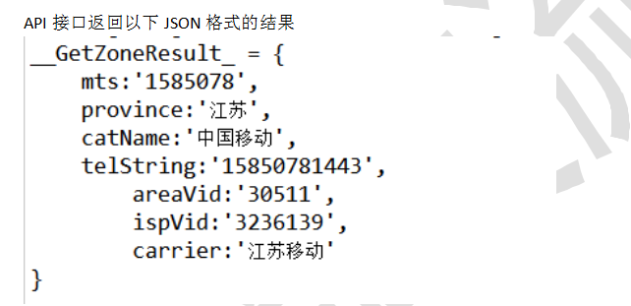

同样的功能还有

调用百度翻译API,调用查询ip地址API,电话号码归属地查询APi，今日头条新闻API

## 3.4 服务层StringService.java

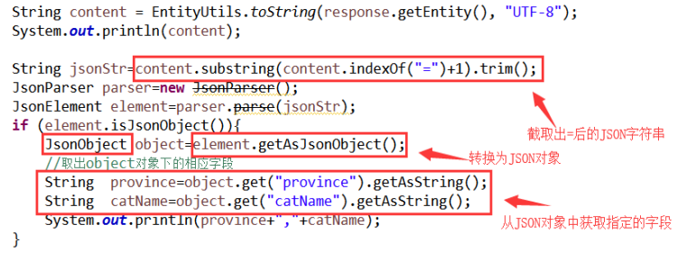

每个API得到的结果内容都是得到不同的json字符串，都需要对json字符串进行解析，并输出打印我们所需要的内容。

## 3.5 用户界面Driver.java

首先本程序的操作界面还是在控制台完成

主函数(主要分为5个功能):

调用菜单函数显示，用户操作选择功能模块

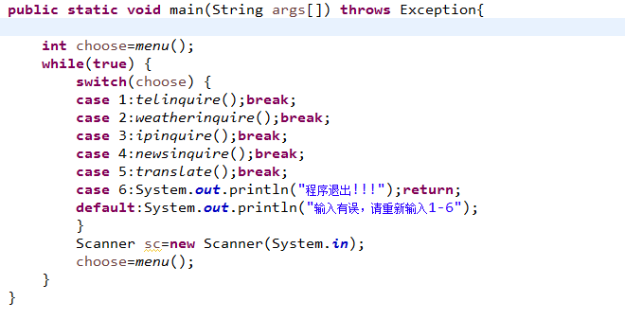

//查询电话的地址

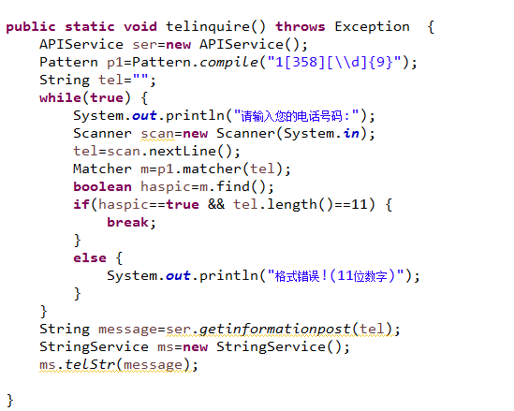

先输入电话号码，用正则表达式匹配，正确之后调用服务层的API访问功能，然后再调用服务层对应的字符串处理功能，输出所需要的信息。

----其它的模块功能类似

//天气预报

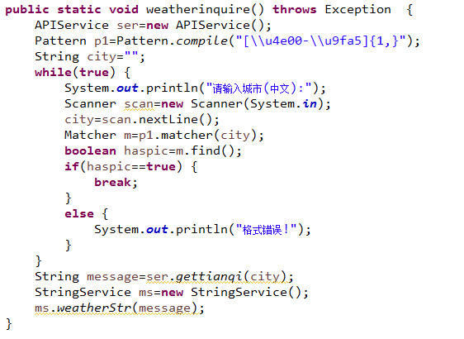

//ip地址查询

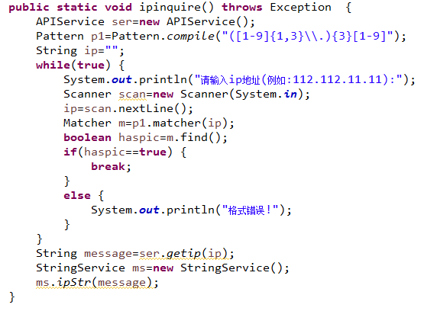

//新闻头条

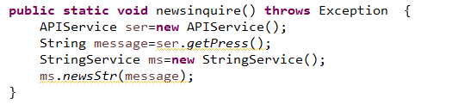

//中英文翻译

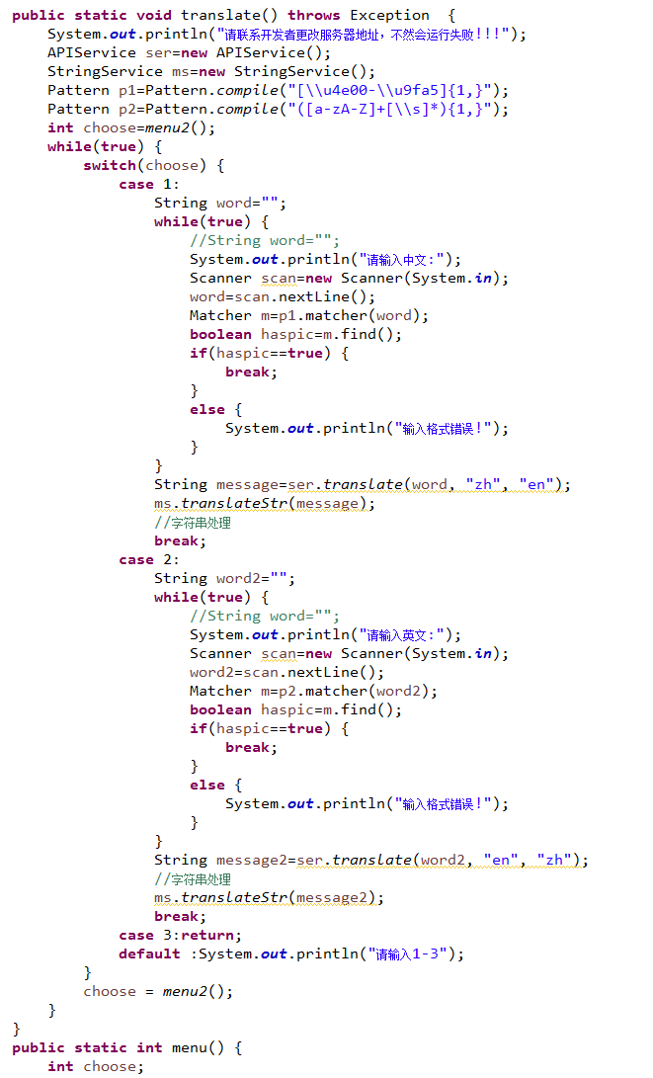

//菜单

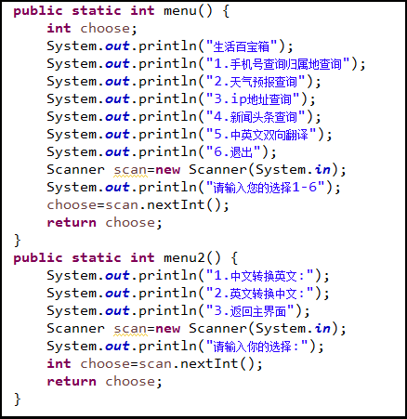

# **4 系统测试**

设计测试用例，给出程序每个功能模块的运行结果截图。

//手机号查询归属地查询

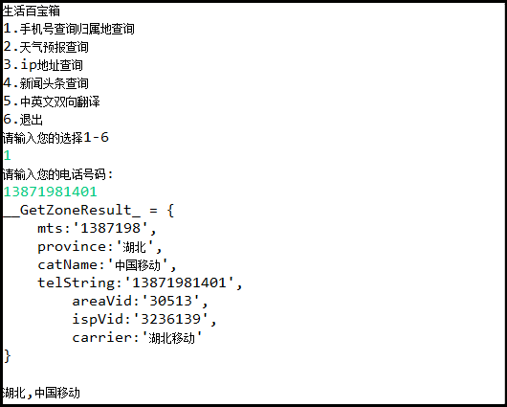

//天气预报查询

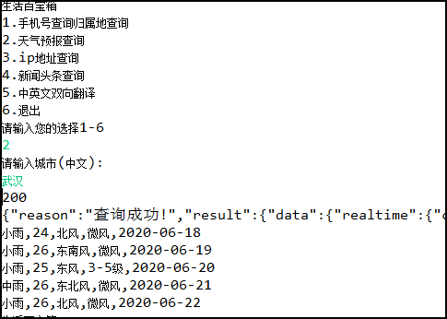

//ip地址查询

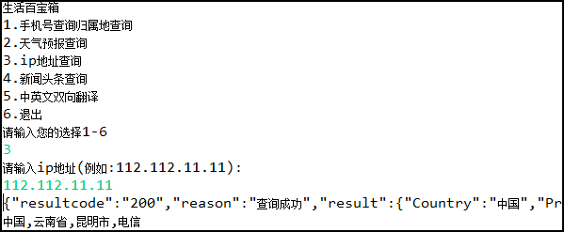

//新闻头条查询

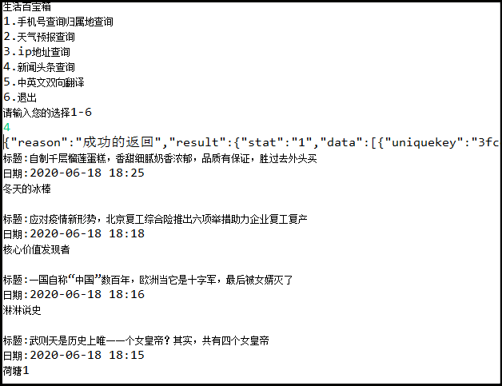

//中英文双向翻译

!!!注意这个功能应该会运行出错，因为API分配了一个IP地址，访问API的电脑的IP地址必须一致，所以请联系开发设计人员修改!!!

-----失败

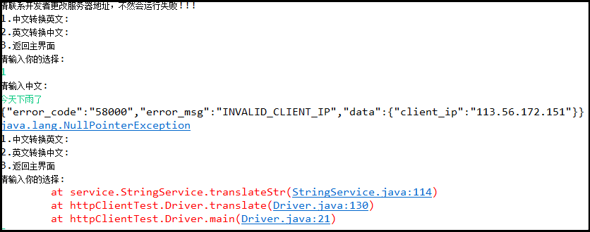

**-----------成功**

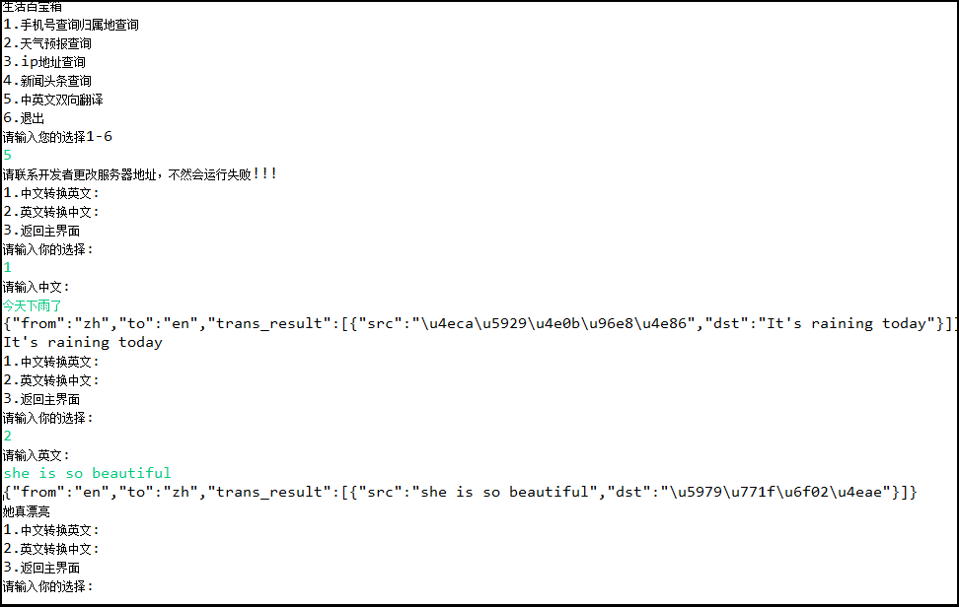

# **5 系统总结**

主要问题的解决过程、系统存在的不足，本门课程的收获，课程的建议，以后的发展方向，自评成绩。

主要解决的问题：

1需要免费调用API，必须得实名注册，每个API分配密钥，稍微有点麻烦

2对json字符串的解析，

解决办法：花时间

系统存在的不足：

1功能弱，本程序只有5个功能

2用户操作只能在控制台操作

3部分功能只能在本机实现，如中英文翻译功能

4可鲁棒性不高等

收获：

进入大学以来，觉得Java是最实用的一门课程，算是对编程有了一定的认识。通过这门课的学习过后，感觉自己的编程能力和学习能力都有了很大的提高，同时也感觉到自己目前所掌握知识的缺乏，还有太多太多的对东西需要我去学习。而且这门课所用到的知识也是非常的综合，数据库编程，网络编程，Android编程等等，非常的实用，对以后工作也有很大的帮助。

对课程的建议：

感觉老师讲的很好，不管是讲课，布置作业，还是编辑的文档，老师都非常的仔细。当然老师布置的所有任务，我也都是自己独立一一完成。要是我们软件工程以后也能开设Java的后期课程就好了，哈哈哈哈

以后的发展方向：

考研，进入一个好的学校提升平台和拓展人脉；发展的语言：Java和Python，理想的发展方向：人工智能，机器学习，深度学习；理想的公司：当然是BAT了；

理想很丰满，现实很骨感，慢慢来吧，take your time！

自评成绩：

课程设计的话：85分；知道自己课程设计没有太下功夫，只是完成了基本的功能

平时成绩：100分，因为感觉自己平时挺努力的（目前下功夫最多的课程，没有之一，而且是线上学习），平时作业都是自己按时独立完成，质量也还行（所以对课程设计就没有太看重）